Advanced Complex Rag Workflow
https://github.com/mistralai/cookbook/tree/main/third_party/langchain
https://www.youtube.com/watch?v=sgnrL7yo1TE
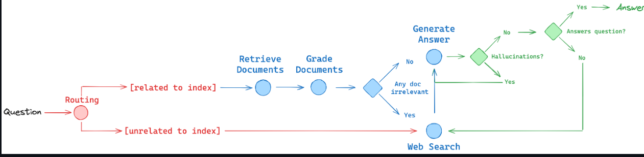
It's based on three papers research papers, Self Rag, Corrective Rag, and Adaptive Rag. The general idea of those papers is to add reflection into our workflow.
So, we want to reflect on the documents that we retrieve and to see if they are indeed correct for us or not (in the grade documents). If documents retrieved are not enough, we want to curate those documents and add new information from web search. (till blue part). After that, (green part) we also want to reflect on the answer. So we want to check if the answer is indeed grounded in the documents, and that the answer indeed answers the question.
And also there is a routing element where we're going to route our request to the correct data store that is going to have the information for our answer. (red part)

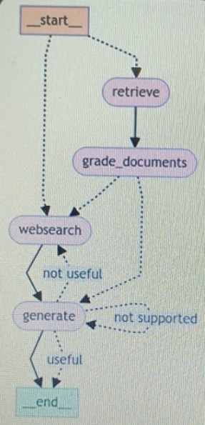

Corrective RAG
- This is an advanced react technique that is going to help us get more quality answers when performing retrieval, augmentation, generation.
- 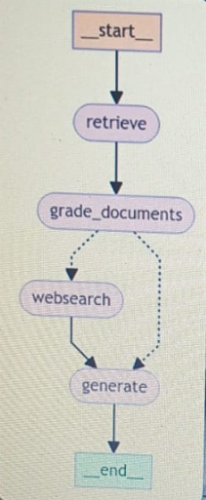
- We first want to start by taking our query performing in the vector-semantic-search and retrieving relevant documents from our vector store. After we have all those documents, we want to start and self-reflect, to critique those documents and to determine whether they are indeed relevant to our original query or not.
- If all of the documents are relevant to our query, then this is a happy flow and we simply want to augment our original prompt and send everything to the LLM like we always do in RAG.
- However, if you find document that we find out that are not relevant to our query, of course we want to filter the null and we also want to perform some external search on the internet and get to more information. And to augment our prompt with that real time information we get from online. And after we have that, we can augment our prompt and send everything to the LLM.
- And this technique is going to give us much more quality response.

Self-Rag
- Self-rag is derived from the self-rag paper and is basically meaning that we are going to reflect on the answer that the model generated.
- So we are going to take the generation and we're going to compare it with the documents, and we're going to see whether the model hallucinated or not. So we need to check whether the answer is actually grounded in the documents.
- Now, if it's grounded, then that's cool and we're ready to the second step.
- And the second step is to reflect on the answer. So, now we want to reflect whether the answer answers the question that the user originally asked. And if the answer is yes for that, then this means we can return the answer to the user.
- And if the answer does not answer the question, then this probably means that we need to make a web search, because we're not going to find any additional information in the vector store.
- And if it hallucinated the answer, that means answer is not grounded in the documents, then we want to regenerate it again and to ground in the documents.
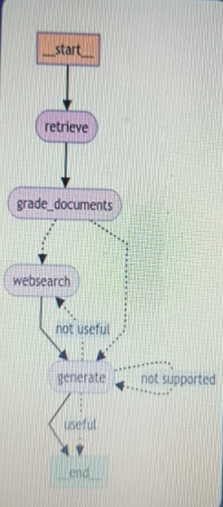

Adaptive-Rag
- 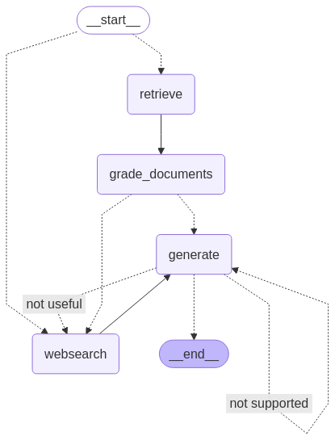
- Simply using a question router to route our question to different rag flows.
- So, in this video we're going to be using two rag flows.
- So, the first one is going to be taking the route to search on the internet and then to continue downstream on the same logic we have before.
- And the second round is going to be to use the retrieval augmentation from our vector store.
- So, we're first going to take the user's question, and we're going to decide whether the information is stored in the vector store to answer that question. And if it's not, we're simply going to take the route to web search and answer from there.

